**Editing an HTML file**

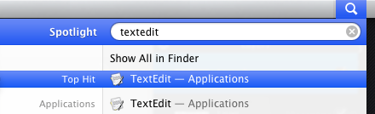

**1) Launch TextEdit –** To launch **TextEdit**, click on the magnifying glass on the upper right corner of the screen and type **TextEdit.** Click on **TextEdit** with your mouse or hit enter.

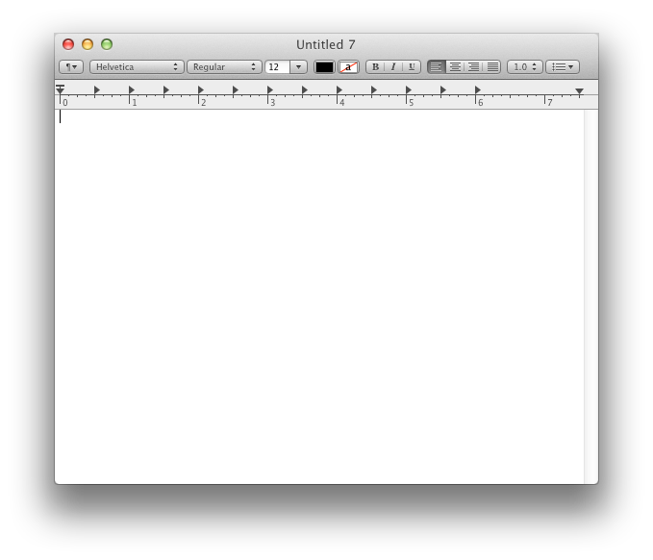

**2) You should see something like this.**

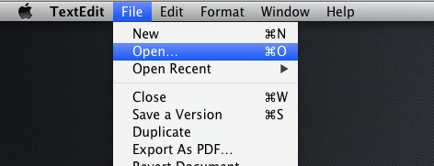

**3)** Now go to the toolbar and click **File >> Open**

**4) A dialog like this should pop up. Double click on the HTML file you want to make changes to.**

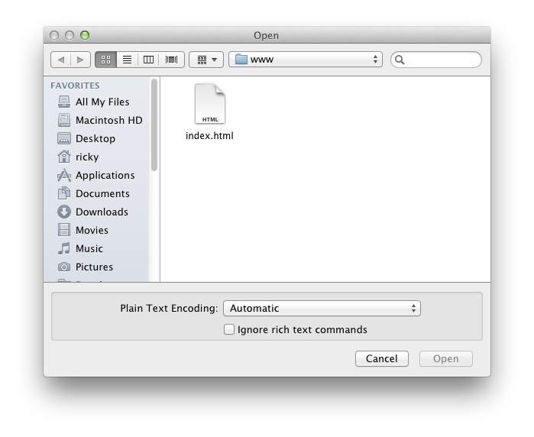

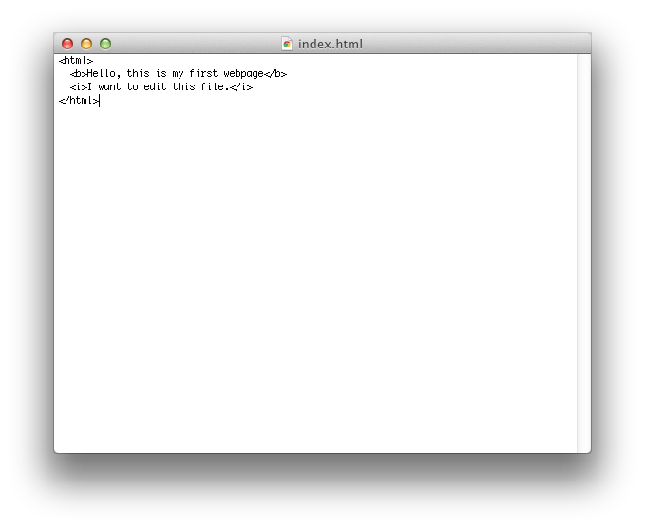**5) Congratulations, you’ve successfully opened your file up. Now you can start making changes to your webpage.**